BUSINESS ENGLISH THEME BASED LESSON Marilyn Mior

A. Warm up
Tell me what the pictures mean to you.
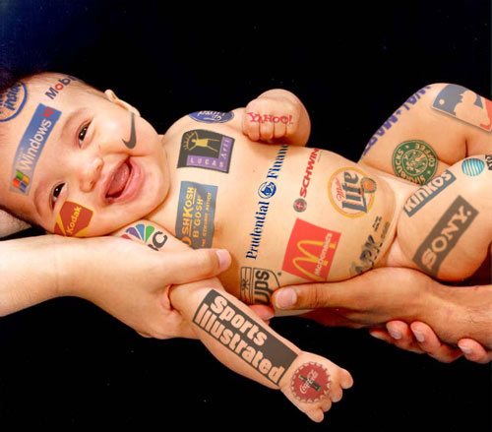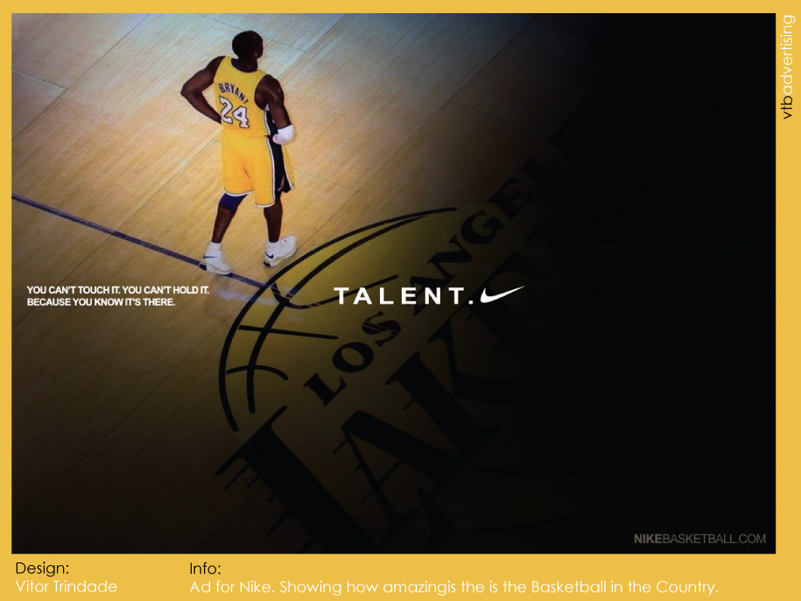

1. Introduction

A) Do you enjoy advertising?
B) What is your favorite commercial? Why?
C) Name me the places where you see advertising.
D) Do you know what the best type of advertising is?
E) Do you think advertising influences our behavior when we buy something?
F) Are you loyal to a specific brand?
G) Do you do impulse buying sometimes?

2. Vocabulary exercise

There are descriptions of people below. Tell me which technique the company should use to attract that consumer. (marketing ethics, niche marketing, brand loyalty, routine purchasing, impulse buying, fast moving consumer goods or consumer durables)
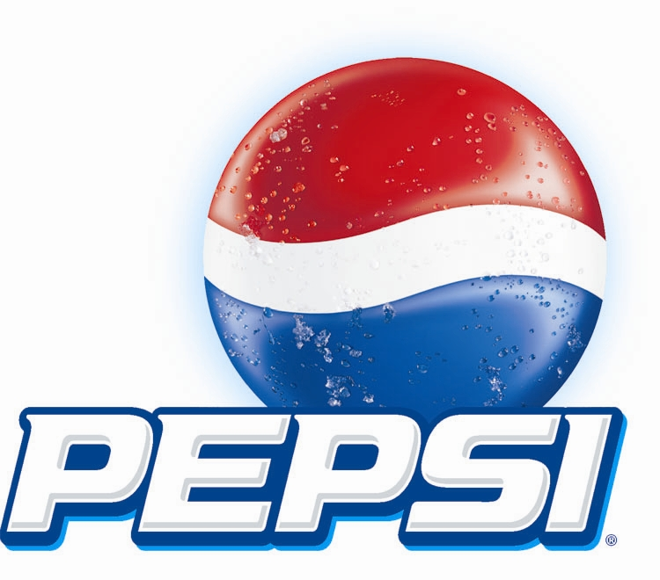

1. I drank Pepsi all my life.
2. I am a mom. I go to the grocery store every week.
3. When I love a shirt that pleases me at the shopping center, I buy it immediately.
4. I am the vice-president of Microsoft. I only buy expensive articles.
5. I am a grand-mother. When I was young, we did not have the money to buy lots of articles so we made sure they will last. Even today, I prefer to buy things that will last a long time.
6. I am a teenager and love to play video games. I buy games as soon as I see them in the store.
7. I am a student. I buy tickets to take the bus every month.

3. Main activity

Dove's Campaign for Real Beauty
In 2004, Dove launched the very successful Campaign for Real Beauty. This campaign took real women, not models, to be part of advertising for a firming cream. This advertisements focus on promoting real, natural beauty, to show real girls that the models do not have the perfect body. They are too thin and it is impossible to be healthy that way. Their slogan is “Real women have curves”. The Campaign for Real Beauty website http://www.dove.us/#/cfrb/ shows quotes of the women who participate in this campaign. They share their opinion about what real beauty is and why they wanted to be a part of the campaign.

Shanel Lu: I love the thought of being a part of an advertisement that would potentially touch many young girls to tell them that it is all right to be unique and everyone is beautiful in their own skin.
Julie Arko: Being a woman is beautiful. Waking up every morning and living a happy, healthy life is beautiful.
Lindsey Stokes: Young girls need to see real women like themselves in print ads or on TV.
Sigrid Sutter: Dove is beauty. I only use that brand. It makes me feel good.
Gina Crisanti: It [the campaign] encourages little girls to forget about the image of the models, who are too skinny. It helps them realize they are beautiful too.
Staci Nadeau: It's time that all women felt beautiful in their own skin. That’s what Dove’s shows us. We don’t have to be rich or a model to be special and use their product.

The Campaign’s Buzz
The Campaign for Real Beauty had a big impact. The six women in the U.S. ads went to national television spots, took pictures for magazine ads, for print ads and billboards in major urban markets in North America (Dove is also running similar campaigns throughout the world). The campaign and its influence on body image received a lot of comments. Some were really good, others were only criticism. The Real Beauty models appeared on a lot of television programs including "Oprah", "The Today Show", "The View" and "CNN".
http://www.media-awareness.ca/english/resources/educational/teachable_moments/campaignrealbeauty.cfm
(I modified it a lot to help students understand and help me with the exercises after it but the basis is the same.)
Questions:
1- Dove focused on a .social problem in their campaign. What is the marketing technique that they used?
2- What are two of the types of advertising that Dove used to promote their campaign?
3- What does Dove want to sell with this campaign and will the people develop a fast moving consumer goods habit with this product?
4- Sigrid Sutter shows us a buyer behavior. Name it.
5- According to Staci Nadeau’s opinion, is Dove doing niche marketing?
6- Are the models in this campaign a type of advertising for Dove?

4. Free exchange

1. Would you like to be part of Dove’s campaign?

2. What is your idea of real beauty?

3. According to your opinion, what is the best type of advertising (ex. niche marketing)? Is Dove using that type of advertising?

4. Does this campaign make you want to buy more of Dove products? Why?
5. What do you think about this campaign? What are the strong sides and the weak ones?

6. Would you like to work for a company like Dove? Would you like to prepare advertising for them?

5. Review

Tell me which type of marketing or buyer behavior is this:

1- Repeat buying, with little involvement in the purchase.

2- You see it, you buy it! (spontaneous decision).

3- Large purchases of products that will be used for a long time.

4- Marketing for rich people, high quality products.

5- A product you always buy. You buy the same brand over many years.

6- Concern for environment, for society and for a moral code in marketing.

7- Regularly used items that are bought frequently.

6. Answer key

1. Introduction

D) Human

2. Vocabulary Review

1. Brand loyalty
2. fast moving consumer goods
3. Impulse buying
4. niche marketing
5. consumer durables
6. Impulse buying
7. Routine purchasing

3. Main activity

1. marketing ethics
2. Internet, television, billboards, newspapers, magazine
3. A firming cream and no because you don’t have to buy it everyday
4. Brand loyalty
5. No
6. Yes. Humans are a vehicle for publicity.

4. Review

1. Routine purchasing
2. Impulse buying
3. Consumer durables
4. Niche marketing
5. Brand loyalty
6. Marketing ethics
7. Fast moving consumer goods (FMSG)

