Canada’s Funny Man Gabrielle Levesque

Introduction

1. What do you think about Canadians?
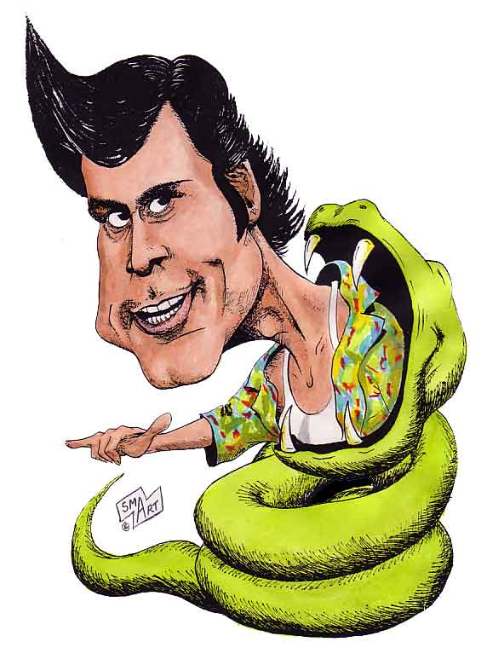
2. Do you think Canadians are more or less funny than other people?
3. What does the title tell you about the main idea of the text?
4. Do you remember some famous Canadians mentionned in the text? Tell me the name of those you remember.
5. Do you like the ‘the instantly recognizable’ Jim Carey? Have you ever seen some of his movies? What ones?
6. In general, what is the text about? Tell me what you remember.
7. Are you a funny person? Would you like do be a famous comedian in the future?

Vocabulary Review

1. Is there something you are unable to do? (art, cooking, sports, …)

2. Jim Carey used to misbehave in class? Do you sometimes misbehave in class?


3. He used to exasperate his teacher. Do you exasperate your teacher?

4. When you were young, was there something you could obtain from your parents in exchange for your good behavior?

5. Do you think Cegep allows us more liberty than high school?


6. Do you know if your parents still pay a mortgage on your house?

7. Do you know people who work as janitors? Do you think it’s a good job?

8. Do you have a job? How do you juggle work and school? Or sports and school?

9. Did any of your friends drop out of school after high school? What does he or she do now?

10. What helps you cope when things get rough? Is it your friends, your activities?


11. Do you know anybody who is an angry loner?

13. Have you ever been booed off a stage?

14. Do you have a trademark comment? Does anybody you know have one?

15. Do you have some expectations when you watch a movie or a television show?

Simple Past Questions and Vocabulary Review

Yes/No Simple Past Questions

- Ask me if I misbehaved in class when I was young.
- Ask me if I wanted to be a janitor when I was young.
- Ask me if my parents paid a mortgage on their house.

Wh-Simple Past Questions

- Ask me what movie I wanted to see last week.
- Ask me what I was unable to do when I was young.
- Ask me how I managed to juggle work and study when I was in high school.

Questions about the text

Paragraph 1

-What do people from other countries think of Canadians?

Paragraph 2

-Who is the most famous Canadian comedian?

Paragraph 3

-How did Jim Carey and people around him find out he was such a funny guy?

Paragraph 4

- What event lead Jim Carey to drop out of school?

Paragraph 5

-Why could we say that Jim Carey is a superstitious person?

Paragraph 6

- Did people instantly like Jim Carey? Explain your answer.
Paragraph 7

- What movies confirmed Jim Carey as a celebrity? (name two)

Paragraph 9

-What three factors made Jim Carey a superstar?

Discussion
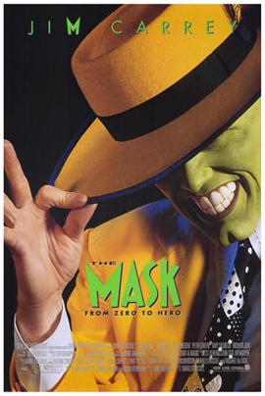
- What did you learn about Jim Carey? Use the past tense.

- According to you, why do people from other countries think that Canadians are boring and not funny?

- What is your favorite Jim Carey’s movie? What do you like in it?

Vocabulary Quiz

- What is the verb used to say that a person is behaving badly?
- What is the name of the money you borrow and have to refund when you buy a house?
- What is the name of the job of a person who cleans a building?
- How do we call a person who is always mad and alone?
- What is the verb used to say that a person leaves school before they finish it.
6. What is a synonym for « can ‘t »?

Answer Key

Introduction : Personal answers.

Vocabulary Questions : Personal answers.

Simple Past Questions and Vocabulary Review :

Yes/No Simple Past Questions : 1. Did you misbehave in class when you were young?
2. Did you want to be a janitor when you were young?
3. Did your parents pay a mortgage on their house?

Wh-Simple Past Questions : 1. What movie did you want to see last week?
2. What were you unable to do when you were young?
3. How did you manage do juggle work and study when
you were in high school?

Questions about the text : 1. They think we are nice, reserved and polite, but not funny.
2. Jim Carey is the most famous Canadian comedian.
3. They found out when his teacher gave him the punishment
of entertaining the class.
4. His father lost his job and couldn’t pay the mortgage
anymore.
5. He wrote a $20 million cheque to himself.
6. No, because he was booed off many stages, he was rejected from Saturday Night Live and his first television show wasn’t popular.
7. Ace Ventura, Pet Detective; The Mask and Dumb and
Dumber.
8. His wild comedy style,his rubber face and his trademark
comment (‘Alrighty then’) made Jim Carey a superstar.
Discussion : Personal answers.

Vocabulary Quiz : 1. To misbehave 4. Angry loner
2. Mortgage 5. To drop out
3. Janitor 6. Unable

