Theme based lesson Gabrielle Lévesque
Daycare
Discussion Questions

- When you were young, did you go to the daycare or did you stay at home?
- Do you think the children in daycare are more likely to misbehave?
- What do you know about the Quebec daycares system (CPE) ?
- Do you think it is an easy job to be an educator?
- Would you prefer to work with babies or with older children if you worked in a daycare?

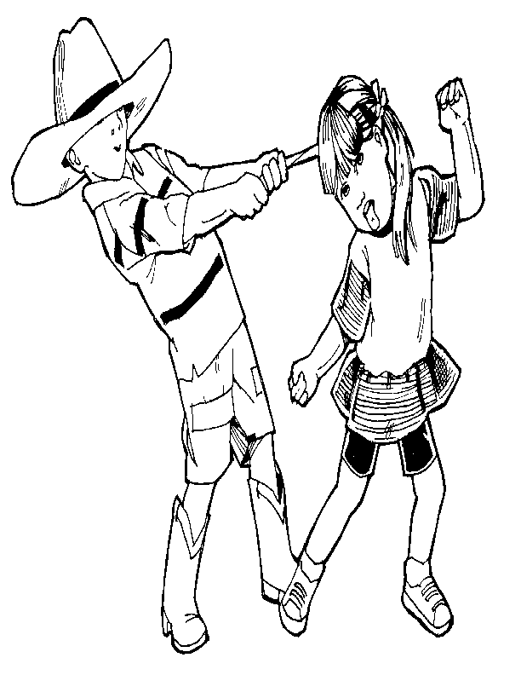
Vocabulary

- Plenty of studies have shown that day care can have many negative effects on children, including increased aggression and stress.
a) less violent acts b) soft violent acts
c) more violent acts d) murders

- The worst cases of misbehavior included children biting, punching, and kicking other children.
a) fighting b) screaming at c) touching d) hurting with their teeth

- […] as well as screaming on a daily basis and having absolutely no respect for the staff or any kind of authority figure.
a) each day b) sometimes c) rarely d) never
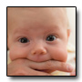
- One three year old would bite himself until he bled if he was angry for any reason.
a) until he gets tired b) until there is blood c) until it hurts d) until the educator tells him to stop

Match the definition

1. Ouch Report a) The child has stress when his parents go to work.
2. Preschool b) The person that takes care of the children at their house.
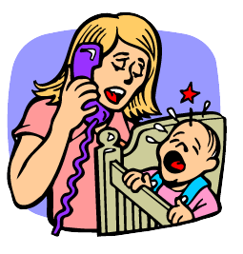
3. Separation anxiety c) The paper given to the parents after the child got hurt.
4. Educator d) To be sad, to have tears.
5. Babysitter e) The person that works in a daycare.
6. Good behavior f) To want to see someone.
7. To cry g) Where children go before their first school year.
8. To miss h) When the child does what he/she is told.

Fill in the blanks with the vocabulary above.
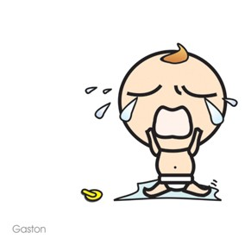
- Lea always ___________ when she doesn’t have enough attention.
- The ____________ must teach the children how to be respectful.
- William has ____________________. All the educators love him.
- Claudia is a _______________. She likes to take care of her uncle’s children.
- Mia is going to _______________. Next year, she will go to kindergarten.

Read the text

Daycares don’t care

Plenty of studies have shown that day care can have many negative effects on children, including increased aggression and stress. My time at the day care proved to me the truth of such statements. With four younger children of my own and many babysitting jobs, it was shocking to me when I first observed the errant behavior of many of the kids at the day care...
Children would often cry for their mothers or fathers all the day, or constantly ask, “When’s my mommy coming to get me?” Besides the desire to be reunited with parents, many kids would act out and misbehave regularly. The worst cases of misbehavior included children biting, punching, and kicking other children, as well as screaming on a daily basis and having absolutely no respect for the staff or any kind of authority figure. One three year old would bite himself until he bled if he was angry for any reason.

Questions

- Does the author think that daycares are good for children? Why?
- Why was the author suprised by the daycares? Does she have any experience with children?
- What are the two things that surprised the author?
- Why does the three-year-old child bite himself? Is there a specific reason?
- Do you think that daycares are good for children? Do you agree completely with the author? Would you send your own kids to daycare?
What do you remember from the text? The main ideas are giving to you. Fill in the supporting ideas.
Name of the institution that takes care of the children : _____________________
Negative effects on children
Experience of the author with children
First problem with children in daycares
Second problem with children in daycares

Role Play

Student : You are an educator in a daycare. A child misbehaved during the day and you have to tell the parent.
Tutor : You are the parent. Ask questions to the educator to know what is the problem with your child.

Answer Key
Vocabulary : 1.c 2.d 3.a 4.b
Match the definition : 1.c 2.g 3.a 4.e 5.b 6.h 7.d 8.f
Fill in the blanks : 1. cries 2. educator 3. good behavior 4. babysitter 5. preschool
Questions about the text :
1. No, because she thinks they can have many negative effects on children. Her experience made her believe the studies that show that.
2. She was surprised because she has four children and she did a lot of babysitting. She never saw any problems like that.
3. Some children cry all day because they miss their parents and some children misbehave a lot.
4. He bites himself whenever he is angry, for any reason.
5. Personal answer.

Negative effects on children | -Increased aggression  -Stress
Experience of the author with children | -She has four children  - She did a lot of babysitting.
First problem with children in daycares | -They cry all day because they miss their parents and they always ask when they are going to come.
Second problem with children in daycares | -She saw the worst cases of misbehavior (children biting, kicking and punhcing other children, a child biting himself.)

Lesson Plan

Objectives : -learn new vocabulary related to daycares
-read about daycare and learn about its effects
- review simple present if necessary

Materials : Daycare worksheet

Warm-up : Review important words from last week, What did you do in class?, Do you have any homework?

Activities :

- Discussion questions
- Go over difficult words (questions+definitions+fill in the blanks)
- The student reads each paragraph silently. At the end of each paragraph, he summarizes it and the tutor asks questions.
- If there is any simple present mistake, the tutor will write them down and will ask the student to correct it.
- Do comprehension questions.
- Ask the student to tell you everything he remembers and to write it down in point form.
- Get them to look for any information they missed in the text.
- Do the role play.
- What do you want to do next week?

