# Theme-Based Lesson: Green Day by Priscilla Ross

## Introduction

Discussion: Do you like music? Do you frequently listen to music? How do you get your music (Itunes, cds, radio…)? Do you know Green Day? Do you like pop punk music? Do you listen to politically engaged artists? (Ask me…)

## Vocabulary

1. Do you often read what music critics say about a cd before you buy music?
2. Do you know a politically engaged artist/music band?

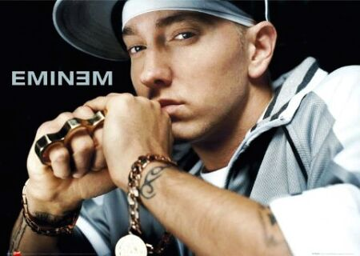

1. Do you care about lyrics when you listen to music?

## Pre-Reading Activity

1. What do you think this text is going to be about?
2. Do you know this band?

## Guided Reading Questions

Read the section *Heirs to the Throne* silently, and then sentence by sentence aloud.

1. Was their teacher right?
2. When did their third album come out?
3. Which American president did they attack with their lyrics?
4. Which prize did they earn?

## Production Task

Green Day writes politically engaged lyrics: will you listen carefully to lyrics when you listen to music? (Ask me if…)

Would you like to try to listen to their old albums? (Ask me if…)

## Review

1. Do you listen to politically engaged artists’ music?
2. Have you ever translated lyrics to know what is a song about?

# Heirs to the Throne: Green Day

## Ages: 30s

## Famous for: Their politics

A ‘green day in hell’ is how 14-year-old Billie Joe Armstrong and Mike Dirnt’s head teacher described their chance of musical success. Now armed with a name, the childhood friends from California went on to prove that teachers aren’t always right! In 1995 their third album *Dookie* put 70s punk rock back on the map – some music critics say the created ‘pop punk’. And the band recently topped their success with *American Idiot*, their most political album to date: its strong attack on U.S. President George W. Bush’s ‘War on Terror’ may have earned Green Day their Grammy for Best Rock Album in 2004. But the band has much more to offer than politics, lead singer Billie Joe points out: ‘We put the fun back in dysfunctional!!’

[](http://videokeman.com/image/pics/GreenDaysongPics1ll4p7f4qpunmcM.jpg)

# Theme-Based Lesson Plan and Answer Key

## Objective:

Increase vocabulary using a magazine article about music

## Material:

‘Rock’s New Royals’ Reading Activity (CLUB#2, November/December 2005)

## Vocabulary:

Answer key:

1. Music critics talk/write about music in media.
2. Example of controversial artist: Eminem
3. Lyrics compose the text of a song.

## Pre-Reading Activity:

Student scans the text to find the subject and the main ideas. Make sure the student looks up for titles, subtitles and pictures, so they could answer better the pre-reading activity questions.

## Guided Reading Questions:

Make them read the section *Heirs to the Throne* silently, and then sentence by sentence aloud. Stop frequently to verify if they understood to practice both understanding and pronunciation.

If necessary, tutor and tutee take turn to read, or use echo reading with student which have great difficulties.

Also, make them summarize what they just read. Make them answer the questions.

Answer key:

1. No, they got musical success.
2. *Dookie* came out in 1995.
3. They attacked George Bush.
4. They won a Grammy.

## Production Task:

Make sure they answer with complete sentences and explanations.

## Vocabulary:

Review vocabulary you just saw in the pre-reading activity. Ask them the questions.