Killing Monsters

Discussion Questions (Before reading)
1. What does the title tell you about the text?
2. In a book, what is the most important for you? Is it the characters, the story or the action?
3. Do you read any comic books?
4. Who is your favorite hero and why is it your favorite?
5. What is interesting about reading comic books?
6. Which one of the comics below seems the most interesting?

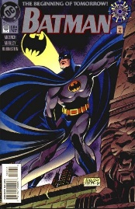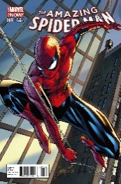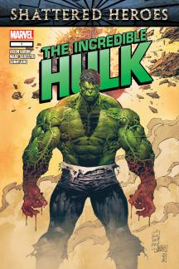

7. Have you ever been to a convention?
8. What is your favorite comic book?
9. Do you think that the presence of violence in comic books is important?
10. Do you know any comic books writer?
Main Idea
In the text ‘’Killing Monsters’’, Gerard Jones, a comic book writer, writes about his love of violence in books as a child and explains how the use of violence in stories can sometimes have a more positive impact on the reader than the story itself.
After reading (Production Task)
1) After you have read the text, is your view on violence in stories still the same? How can violence in those stories have any good impacts on the young people reading them?
2) Could you tell me some good examples of violence in movies and books? Could you tell me some bad examples of it?

By Darren Lepage

