Reasons to take a Gap Year
Ariane Clossey-Fortin
Marie-Noël Thibodeau

- Would you take a gap year (explain what it means if the tutee does not know)?
- Where would you like to travel during your gap year?
- Do you think taking a gap year would help a student be more focused? Why?
- In which picture do people speak a foreign language? Explain why.


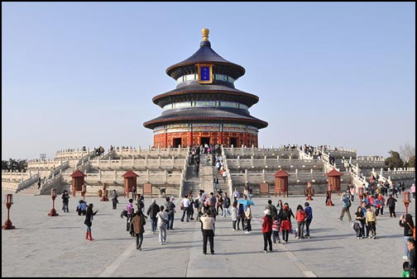

- Sometimes, people do volunteer work during their gap year. Do you know someone who does volunteer work? Who?
- How can people make a wise use of their time during a gap year?
- Could you give me an example of something that is meaningful for you?
- A soft skill is having interpersonal communication skills in order to work well with others. Which one in these pictures does not represent a soft skill?

Teamwork Emotions Hip Hop Dancing




- What do you think a year off could give you as benefits?
- Do you think a gap year is for everyone? Why or why not?

Production Task:
The tutor is an old friend of the tutee. The tutee is taking a year off. It’s been a while since they did not talk so the tutor calls his friend, the tutee.
Tutor: Ask questions about the gap year based on information from the text
Tutee: Answer as much as you can and ask questions about what is going on in the tutor’s life.

Summary: The main idea of the text is to inform students about the benefits of taking a year off school before University or College.

