 Spiderman gloves 
- Theme-based activities -
Marc-Antoine Fiset
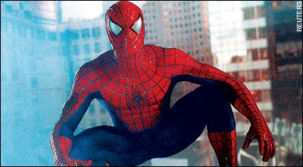

Discussion Questions:
- If you were a superhero, what powers would you like to have?
- How do you feel about technology?
- What would you do if you could scale walls like Spiderman?
- How do you think geckos stick on the surfaces they climb?
- What are possible applications of sticky gloves?

Vocabulary Exercice:
- Match the words bellow to the pictures. (Two words can go with only one picture)

Gloves

To scale

Gecko

To stick

To climb

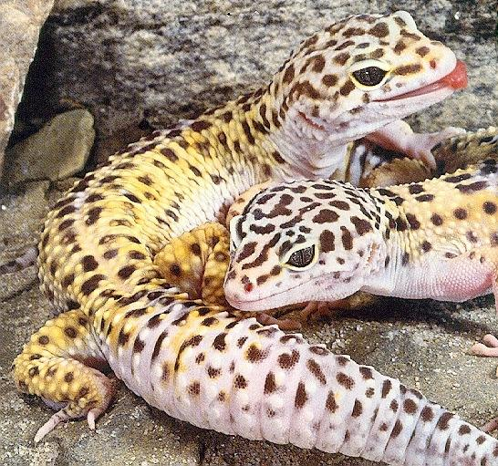
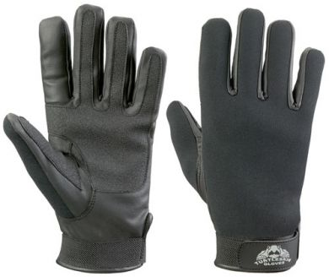
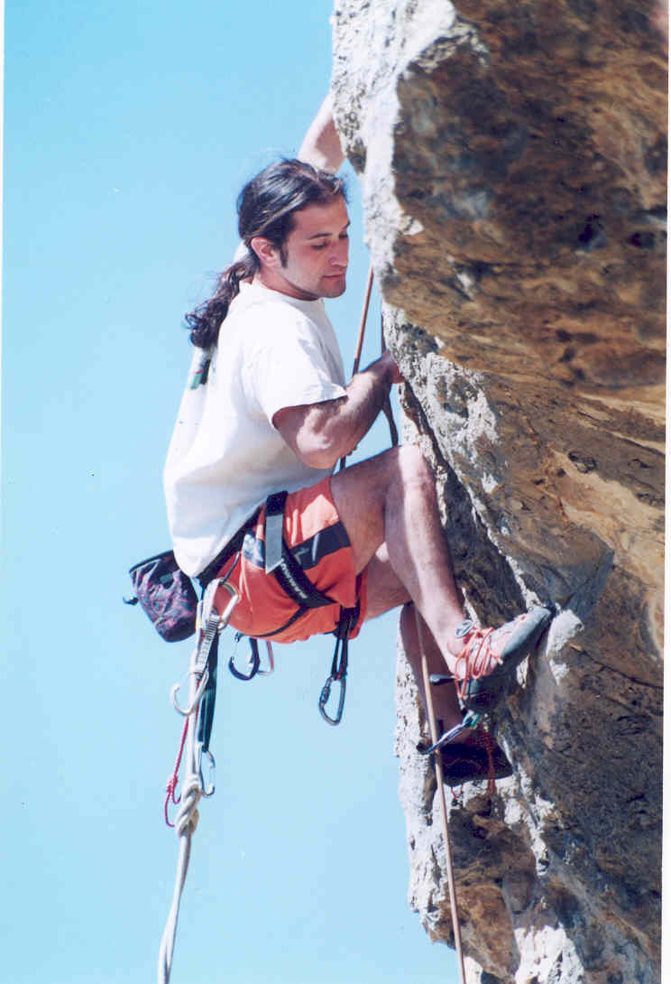
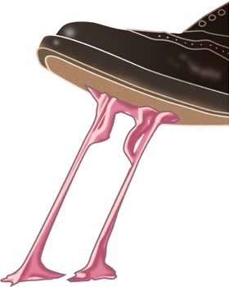

2.
a) It is so cold outside, I forgot my ______ home.
b) -Hi sir, welcome in the lizard section of the pet shop, may I help you ?
-Yes, I was looking for a ______.
c) I love spring and nature. I especially appreciate maple toffee on snow at a sugar shack. It just ______ a little bit.
d) The monkey is a famous animal. It _____ easily in the giants trees of its habitat.
Short article about Spiderman gloves :

Soon, gecko lizards inspired 'Spiderman gloves'
Posted on 23 Jan 2008 by HimTimes
London, Jan 23 : Your dreams of scaling walls like Spider-man may soon be a reality for researchers at the University of California who are developing gecko-gloves for the comic hero type climbing.
The research team have reported that they have solved the mystery of how the lizards manage to stick without getting stuck.
"I think gecko-gloves for Spiderman type climbing could be made in three to five years," said Prof Ron Fearing of the University of California.
The researchers said that while conventional adhesive tape sticks when pressed on a surface, the new gecko-inspired adhesive only adheres when it slides. It exploits the same effect that allows a real gecko to run up walls while rapidly attaching and detaching its toes.
The gecko-inspired smart adhesive, which is dry, uses hard plastic microscopic fibers of polypropylene that mimic this effect.
As for the prospect of spidey gloves, "of course, climbing would require a good athlete, and it would probably be a good idea to have some extra contact area such as pads on knees, chest, and so on. There are issues remaining to be solved, as in sticking to dirty or rough surfaces, such as you would find on the outside of a building," said Prof Fearing.

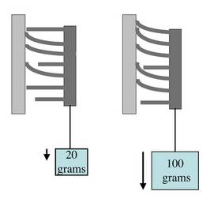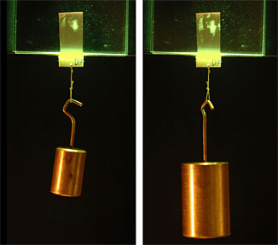
The weight increases retention as shown on the two pictures above. On the right side, the
green spots represents adherence.

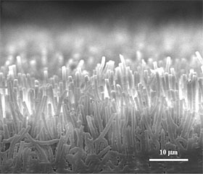
Microscopic fibers of polypropylene that stick on the
surface.

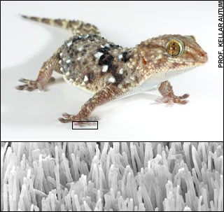
Microscopic hairs on geckos hands and feet.

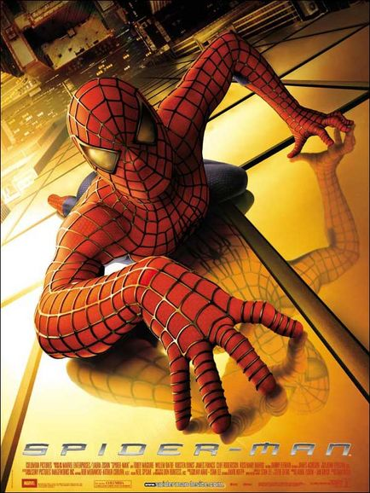
The famous superhero of Marvel on a building.
Questions:

1. Which university are the researchers who are working on the Spiderman gloves from?
a) University of Los Angeles
b) McGill University
c) University of California
d) University of Indianapolis

2. Is the adhesive dry or humid?

3. According to Professor Ron Fearing, when might the gloves be made?

4. True or false: Conventional adhesives only stick when sliding on a surface.

5. What is the problem that must be solved now before making the gloves?

6. What is the natural inspiration for the gloves?

Final Activity:

Guided role play:

The student is Professor Ron Fearing from University of California. The professor is interviewed by a reporter, the tutor. The pictures contain the vocabulary of the activity so the student can think to include the new words. The tutor can decide to use the pictures or not to use them.

Interviewer: Hi Professor Fearing, can you tell us about the Spiderman gloves?

Professor Fearing: Yes, yes, of course, sir. The synthetic fabric (the glue) is really different from the adhesives we know. The ________ will be made of a _______ material that imitates

__________________________________.

Interviewer: How does this mechanism works?
Professor Fearing: Well the geckos use their unique skin to ___________________________________. We recently discovered the mechanisms behind their spectacular ability.

Interviewer: Why don’t the geckos slide or get stuck?

Professor Fearing: This is because the skin of their hands is made of thousands of little hair. As this picture shows, the weight increases ________________.

Interviewer: And what would be the use of such gloves?

Professor Fearing: Well if this project really comes to a happy ending, we could possibly use the synthetic fabric__________________________________________________________ ______________________________________________________________________________________________________________________________________________________________.

Interviewer: Thank you Professor and good luck with your upcoming challenges!

Professor Fearing: Thank you!

 Spiderman gloves 
- Theme-based activities - ANSWERS
Marc-Antoine Fiset
Vocabulary Exercice:
- Match the words bellow to the pictures. (Two words can go with only one picture)

Gloves

To scale
Gecko

To stick

To climb

2.
a) I

2.
a) It is so cold outside, I forgot my ______ home.
b) -Hi sir, welcome in the lizard section of the pet shop, may I help you ?
-Yes, I was looking for a ______.
c) I love spring and nature. I especially appreciate maple toffee on snow at a sugar shack. It just ______ a little bit.
d) The monkey is a famous animal. It _____ easily in the giants trees of its habitat.

Questions:

1. c) University of California

2. The adhesive is dry.

3. "I think gecko-gloves for Spiderman type climbing could be made in three to five years"

4. False

5. The adhesive doesn’t stick on dirty rough surfaces.

6. The inspiration is the gecko.

Final Activity:

Interviewer: Hi Professor Fearing, can you tell us about Spiderman gloves?

Professor Fearing: Yes, yes, of course, sir. The synthetic fabric (the glue) is really different from the adhesives we know. The gloves will be made of a sticky material that imitates the sticky hands and feet of the gecko when climbing.

Interviewer: How does this mechanism works?

Professor Fearing: Well the geckos use their unique skin to climb (or stick) on almost every surface. We recently discovered the mechanisms behind their spectacular ability.

Interviewer: Why don’t the geckos slide or get stuck?

Professor Fearing: This is because the skin of their hands is made of thousands of little hairs. As this picture shows, the weight increases adherence.

Interviewer: And what would be the use of such gloves?

Professor Fearing: Well if this project really comes to a happy ending, we could possibly use the synthetic fabric to wash windows easily, for robots in the space or on earth, for fun (liberty to the student to tell ideas).

Interviewer: Thank you Professor and good luck with your upcoming challenges!

Professor Fearing: Thank you!

Adapted from the original article found at http://www.himtimes.com/science&tech/science&tech.php?subaction=showfull&id=1201095337&archive=&start_from=&ucat=10&
The pictures have no particular role. They are just provided to get the activity nicer and to ease the understanding of the article. If I had to use them anyway, I would take them as a base to get the student to speak about what he understood of the text, to summarize.

