Ultimately, It’s About Having Fun Review Sheet
Olivier Tremblay
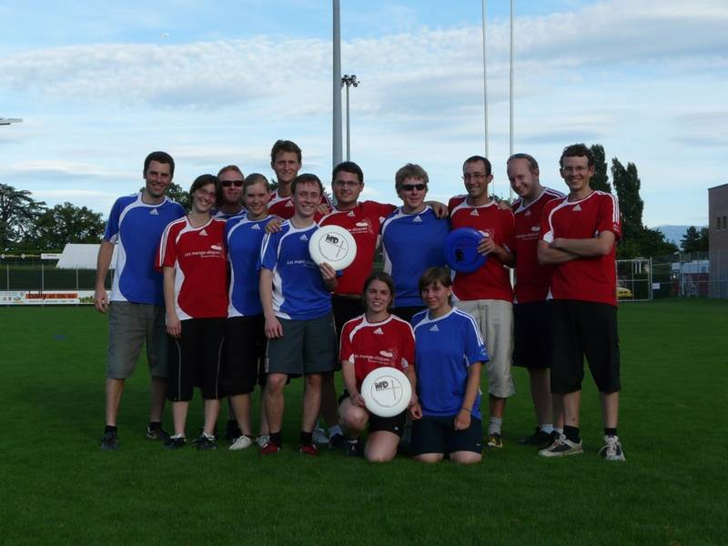

Introduction
- What does the title tell you about the main idea of the text?
- What do you think the text will be about?
- Who is the author of the text and which newspaper is she working for?
- What is happening in the picture in the book?
- Do you do a lot of sports? If yes, do you play for fun or for the competition?
- What is the most important thing for you in a sport: winning or participating?
- Do you play in a sports league?

Vocabulary
- How many players can you see in the picture in the book?
- What shape is the Ultimate Frisbee disc ? 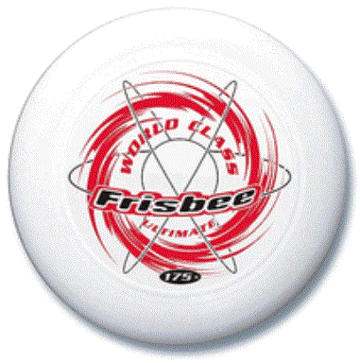
- Are you a veteran in any sport ?
- Is Ultimate a male sport, a female sport or a coed sport ?
- Is the man in good shape ? 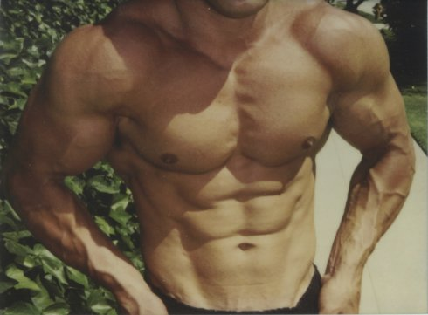
- Are you in a good physical shape ?
- Is Ultimate an indoor or outdoor sport ?
- In general, do you prefer individual or teams sport ?
- What is a referee ?
Grammar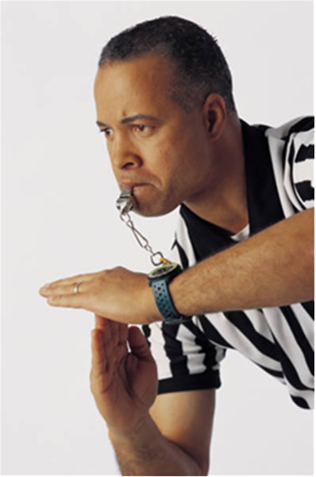

Yes/No Simple Present ‘’to be’’ questions
- Ask me if I am in a sports league.
- Ask me if I am an Ultimate player.
- Ask me if my brother is an Ultimate player too.
- Ask me if I am a good Ultimate player.

Wh ‘’to be’’ questions

- Ask me what color my Ultimate Frisbee disc is.
- Ask me who the inventors of this sport are.

Yes/No Simple Present questions
- Ask me if I like to play Ultimate.
- Ask me if there is a referee in this sport.
- Ask me if this sport is hard.
- Ask me if I have fun in this sport.

Wh- Simple Present questions
- Ask me how often I play this sport.
- Ask me why I like to play Ultimate.
- Ask me how many players there are in a team
Text
Paragraph 1
- Why did Joanne Minns want to join the Ultimate Association? (To meet new people)
Paragraph 2
- True or False: Joanne Minns is obsessed with this new sport. ( True)
- Does she play Ultimate a lot? ( Three or four times a week in summer and once or twice a week in winter)
- True or False: Toby Goodfellow is a new player ( False, he is a veteran)
Paragraph 3
- Is it a popular sport? Explain (around 1700 players in 90 teams in the Montreal Indoor league)
- Were the inventors interested in sports or not? ( No, because they were a nerdy bunch of new Jersey kids)
Paragraph 4
- Do you hit people in this sport?( No)
- What abilities do you need for this sport? ( Speed, agility and the ability to throw a disc with precision)
Paragraph 5
- Who said that Ultimate was about fun, fair play, and trusting the other person? ( Joanne Minns)
Paragraph 6
- What is the most important fact in Ultimate?( The spirit of the game)
Paragraph 7
- How old is Mike Kropveld? ( 55 years old)
- Is Ultimate a coed sport? ( Yes)
Paragraph 8
- Why did Kropveld have a great time? (Because he played in different teams with players of all ages)
- True or False: Kropveld wants to stop playing Ultimate. ( False, not anytime soon)
Free Exchange
- Do you think this sport is easy? Why or why not?
- Would you like to join the Montreal Ultimate Association?
- Do you think Toby Goodfellow is right when he says that you can have more fun playing the game than winning?
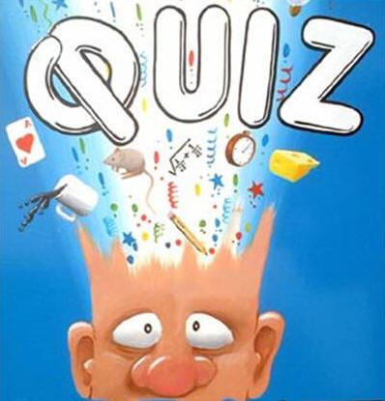
!!!! Vocabulary Quiz !!!!
- What is a sport veteran? An experienced player (Are you a veteran in any sports?)
- What is the term to use when you want to say a mixed team? A coed team (Is Ultimate a coed sport?)
- Who can call the penalties in a sport? The referee (Is it true that Ultimate doesn’t need any referees?)
- When you train a lot, you could say that you are in a good … ? Shape (Do you need to be in a good physical shape to play Ultimate?)
- What is the object you need in Ultimate? A Frisbee disc (Did you ever throw a Frisbee disc in a straight line?)
Good Luck!!!/ /Bonne Chance!!!
