Weed Your Way Around the World

Pierre-Emile Charest and Emile Chamoun

- After reading the title, what will the text be about?
- Do you often do volunteer work?
- Does your family do square dancing in Christmas parties?
- Do you smell the manure of the cows when you are on your way to the CEGEP?
- Would you work for food and accommodation in another country instead of money?
- During summer do you remove weeds from your garden?
- Would you rather stay in a hostel or a hotel?
- Have you ever taken a mud bath?
- Are you a lazy person?
- Do you know any other ways than traditional tourism to visit other countries?


(4.)

(7.)

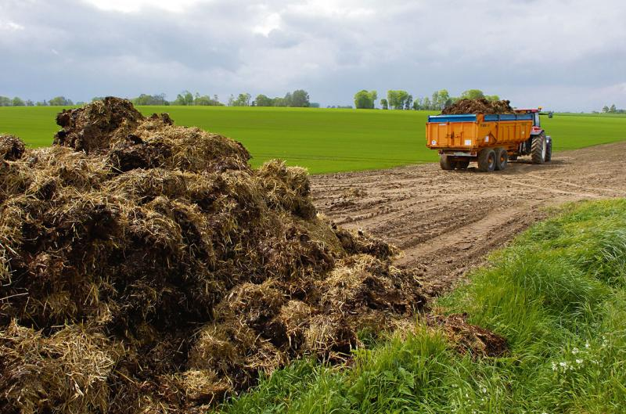
(1.)

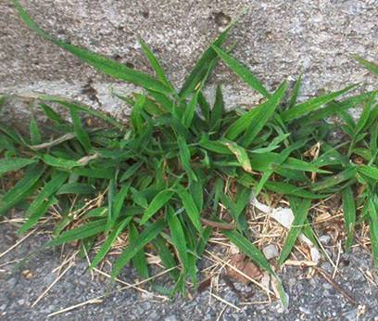

(6.)

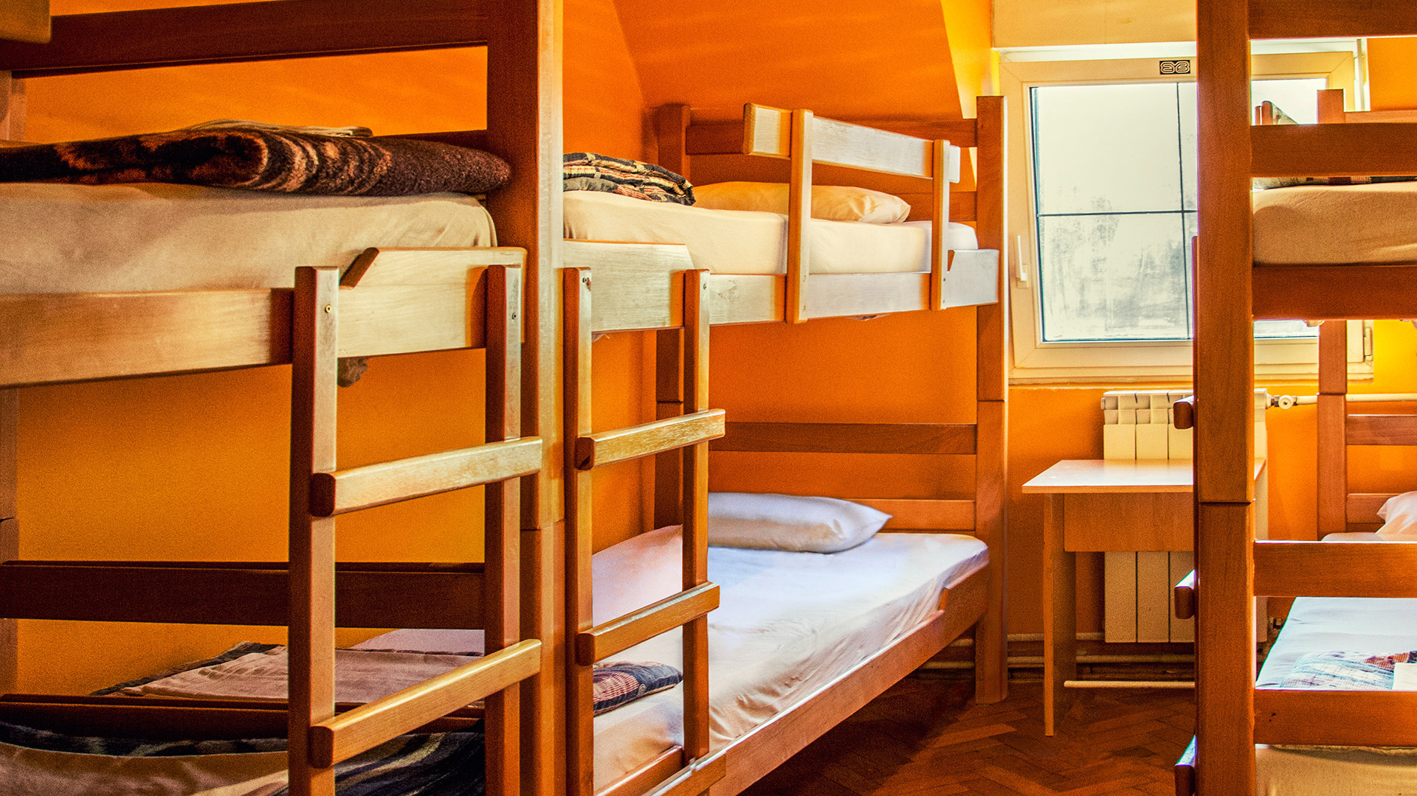
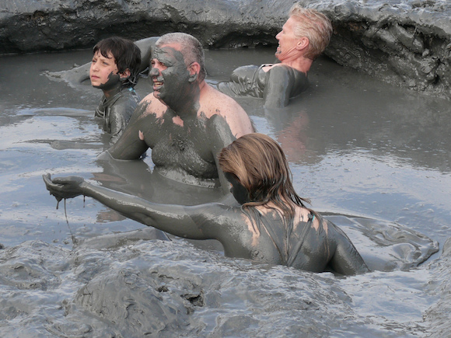

(8.)

Main idea

In the text ‘’Weed Your Way Around The World’’, the author describes what WWOOFing (World Wide Opportunities on Organic Farms) is like.
Production task

Tic-tac-toe
Garden every week | Smell cow manure | Take a mud bath twice a day
Live in a hostel | Remove my neighbours’ weeds | Volunteer for CEGEP activities
Like square dancing | Visit a new country during spring break | Work on a farm

Instructions: Choose one of the verbs and make a true sentence about yourself.

Discussion questions

Instructions: Discuss the questions written below with the tutor.

-Would you rather get paid with food and accommodation in another country instead of having a salary in Québec? Why?

-If you were traveling in another country, would you rather stay in a hotel or experience WWOOFing? Why?

