**I Have a Dream TUTEE COPY**

Adapted from the article “Elon Musk’s college pal: This is what differentiates Elon from the rest of humanity”, *CNBC*. <https://www.cnbc.com/2019/12/20/elon-musks-college-friend-on-why-hes-different-from-everyone-else.html>

**Elon Musk’s 5 Secrets to Success**

Elon Musk is an innovator. He founded PayPal, SpaceX and Tesla. Here are five comics that help reveal how Musk achieved his dreams so you can too.

1. Read to Lead

Elon Musk read the entire Encyclopedia Britannica as a child and continues to read a lot. Follow his example and read books that will give you new ideas. It's no surprise that the greatest readers are the most successful in society.



1. Take Risks Before Life Gets in the Way

The best time to be an entrepreneur is when you’re young. As you get older, risk-taking impacts your family and children. Instead, take risks now when you don’t have these other obligations.

Picture 1 Picture 2 Picture 3 Picture 4

1. Work Hard

Elon Musk often works up to 100 hours a week. So, remember Elon next time you feel exhausted and unmotivated. He’s constantly pushing himself. If you’re not doing the same, you are wasting your potential.

1. Plan for Success, but Prepare to Fail

You should put a lot of effort into following your dreams. At the same time, be ready in case it doesn’t work out. It’s easier to recover from a failure if you have a backup plan.

1. Find the Good in What You Do

You don’t have to completely change the world to “do good.” Look for a positive cause in the work you do. No matter how small, it will help you be more motivated.

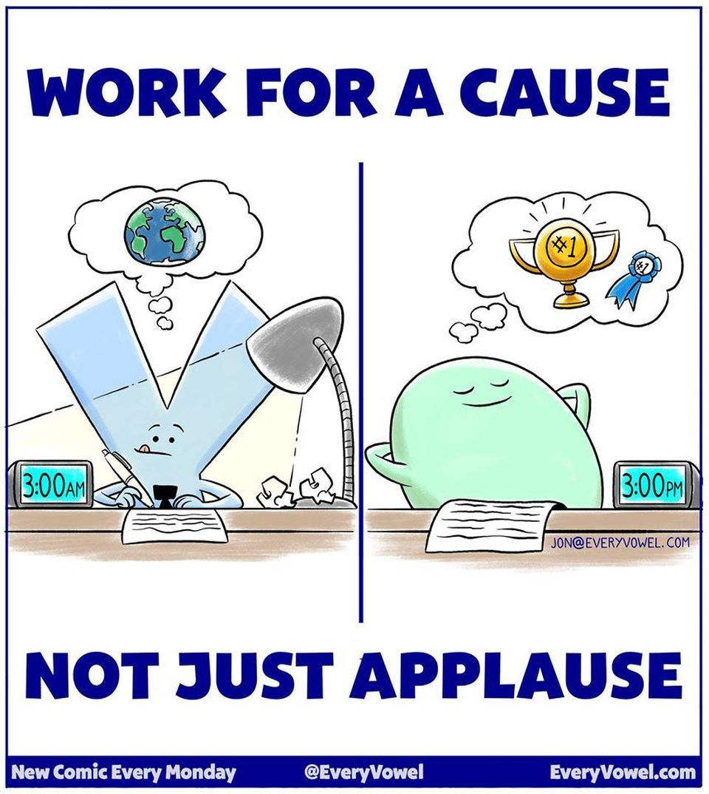

No matter what your goals are in life, adopting the habits and mindset of Elon Musk will help you get there. The extra effort you put in your work today will have a big impact tomorrow.

Comics and article adapted from the article “Elon Musk's 10 Secrets To Success”, *Forbes*. <https://www.forbes.com/sites/jonyoushaei/2018/03/06/elon-musks-10-secrets-to-success/#4ccf1717281e>