**I Have a Dream TUTOR COPY**

1. **Assessment**

**Tutor Instructions: Ask your tutee the following questions and show them the questions if they don’t understand.**

* 1. What is your biggest dream in life?
  2. Do you think you have the motivation and perseverance to achieve your goals? How can you achieve it?
  3. Ask me what’s my biggest dream in life.

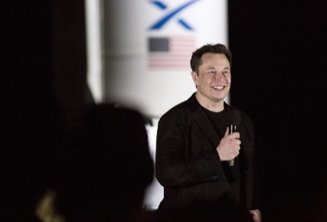

*Elon Musk is the CEO of Tesla. Tesla is one of the first companies to build and sell electric vehicles. It was the first one to integrate Autopilot into cars, video games into dashboards and make firmware updates to improve the cars. Recently, Tesla presented its first pickup, the Cybertruck.*

Adapted from the article “Elon Musk’s college pal: This is what differentiates Elon from the rest of humanity”, *CNBC*. <https://www.cnbc.com/2019/12/20/elon-musks-college-friend-on-why-hes-different-from-everyone-else.html>

* 1. Do you know who he is?
  2. What do you know about Elon Musk?
  3. Did you know Elon Musk founded PayPal? Do you know what PayPal is? *PayPal is an online payment system.* Do you ever use PayPal? For what?
  4. Did you know Elon Musk founded SpaceX? Do you know what SpaceX is? *SpaceX is a company developing reusable rocketships.*
  5. Do you think he worked hard to achieve what he wanted?
  6. Do you want a Tesla?
  7. Ask me if I want a Tesla. Why or why not?

1. **Theory**

**Tutor Instructions:** Explain to the tutee that the following questions contain vocabulary they will see in the text.

1. Do you like to **take risks**? Why? For example, did you ever take a risk and ask someone you have a crush on to go on a date.
2. When was the last time you felt **exhausted** and **unmotivated** at school?
3. Do you **waste** a lot of time? Doing what?
4. Can you describe a situation in which you were scared of the **outcome**?
5. Did you ever **fail** at something? How did you **recover** from this failure?
6. Do you want to start your own **business**?
7. What **comics** do you like to read?
8. What words did you just learn?

**C. Exercises**

**Tutor Instructions:** Ask the questions below to your tutee after s/he reads the title, a heading, a text or looks at a comic from the article “Elon Musk’s 5 Secrets to Success”.

**Title**

1. Read the title and the introductory paragraph. What will you learn in this text and how?
2. **Read to Lead**

**Tutee Instructions:** Read the heading.

1. What do you think it means?
2. What should you do to become a leader? *I should read to become a leader.*
3. Do you agree? Why or why not?
4. Ask me if I agree.

**After the tutee reads the text:**

1. What did Elon Musk do when he was a child? *He read the entire Encyclopedia Britannica when he was a child.*
2. Do you like to read books? *Ask me.*
3. What book are you reading now for your French course?
4. 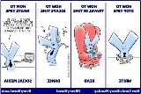What is the benefit of reading books? *Reading books will give you new ideas.*

**After the tutee looks at the comic:**

1. What can you do to use your time wisely? *I can write and read.*
2. How can you lose time? *Dance and be on social media.*
3. Do you agree? Why or why not?
4. **Take Risks Before Life Gets in the Way**

* What should you do before life gets in the way? *Take risks.*

**After the tutee reads the text:**

* When should you take risks? Why? *I should take risks when I am young, because when I get older, risk-taking also impacts my family and children.*

Read the title of the comic. What does “Entrepreneurship in a nutshell” mean? *It means it is a brief summary of what setting up a business is like.*

**After the tutee looks at the comic:**

First picture:

1. What is the blue character holding in his arms? *He is holding plane parts in his arms.*

1 2 3 4

1. Where is the blue character? *He is near a cliff.*
2. What does this picture tell you about setting up a business?

Second picture:

1. What happens to the blue character? *He falls down the cliff.*
2. What does the blue character have in his hand? *He has a hammer.*
3. What is the blue character doing with the hammer? *He is building a plane with the hammer.*
4. Is the blue character taking risks by building an airplane while falling down a cliff? *Yes, he is taking risks.*

***Tell the tutee:*** *It is like an entrepreneur who takes risks.*

Third picture:

1. Does the blue character finish building the plane? *Yes, he finishes building the plane.*

Fourth picture:

1. How does the blue character escape death? *He flies the plane.*
2. What does the picture tell you about being an entrepreneur? *An entrepreneur takes risks and escapes failures.*
3. **Work Hard**

* Do you work hard in CEGEP? *Ask me.*

**After the tutee reads the text:**

1. How many hours does Elon Musk work per week? *He works 100 hours a week.*
2. Who should you remember when you feel exhausted and unmotivated? *I should remember Elon Musk.*
3. What can you do to work hard? *I can push myself.*

**After the tutee looks at the comic:**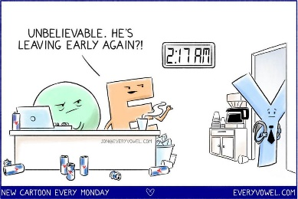

1. What is the blue character doing? *He is leaving.*
2. What time does the blue character leave? *He leaves at 2:17 am.*
3. Do you think he has been at work a long time? Why? *Yes, because the other characters think the blue one is leaving early.*
4. Do you think the blue character is lazy and does not work hard enough? *Ask me.*
5. How many hours do you work each week? *Ask me.*
6. How many hours do your parents work each week? *Ask me.*
7. How many hours do you practice sports each week? *Ask me.*
8. **Plan for Success, but Prepare to Fail**
9. What should you plan? *I should plan for success.*
10. What should you prepare for? *I should prepare to fail.*

**After the tutee reads the text:**

1. If there is something important to you, like a dream, what should you do? *I should put a lot of effort into following my dreams.*
2. What should you have in case of failure? *I should have a backup plan.*

**After the tutee looks at the comic:**

1. Read the title. In your own words, explain the evolution of Elon Musk’s creative idea of making cars electric. *Possible answer: First, he thought it was a great idea, but then realized it would be very hard to make it real. He thought Tesla had a 10% chance of success and that his idea was stupid. But, when he saw the first customers buy his cars, he changed his mind and saw the idea of making cars electric as an awesome one.*
2. Do you feel the same way when you have a new idea? *Ask me.*
3. **Find the Good in What You Do**

* What do you need to find in your work? *I need to find the good in my work.*

**After the tutee reads the text:**

What should be the purpose of your work? *The purpose of my work should be to “do good”.*

**After the tutee looks at the comic:**

1. 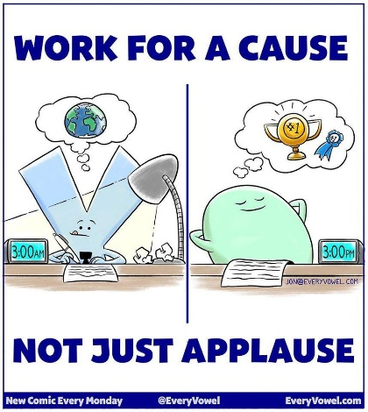What should you work for? *I should work for a cause.*
2. What is the blue character thinking about? *He is doing some good in the world.*
3. What is the green character thinking about? *He is thinking about winning prizes.*
4. What do the clocks in the comic tell you? *The blue character works at 3:00 am, but the green character relaxes at 3:00 pm.*
5. Which character works the hardest? *The blue character works the hardest.*
6. Which one is more motivating: working for a cause, or for a prize? *Working for a cause is more motivating than working for a prize.*

**D. Production Task**

1. What are the five pieces of advice to become successful like Elon Musk?
2. Which piece of advice do you think is the most important? *Ask me.*
3. Do you have other advice on how you can achieve your dreams?

**E. Final Review**

1. Do you think Elon Musk will continue to create **game-changing** products?
2. Are you afraid of **failure**?
3. Do you find studying in CEGEP **exhausting**?