**Tutee’s Copy**

**Trips around the world** Philippe Marcotte

**1**

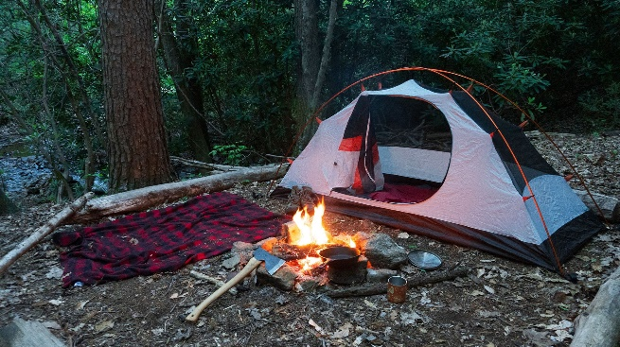

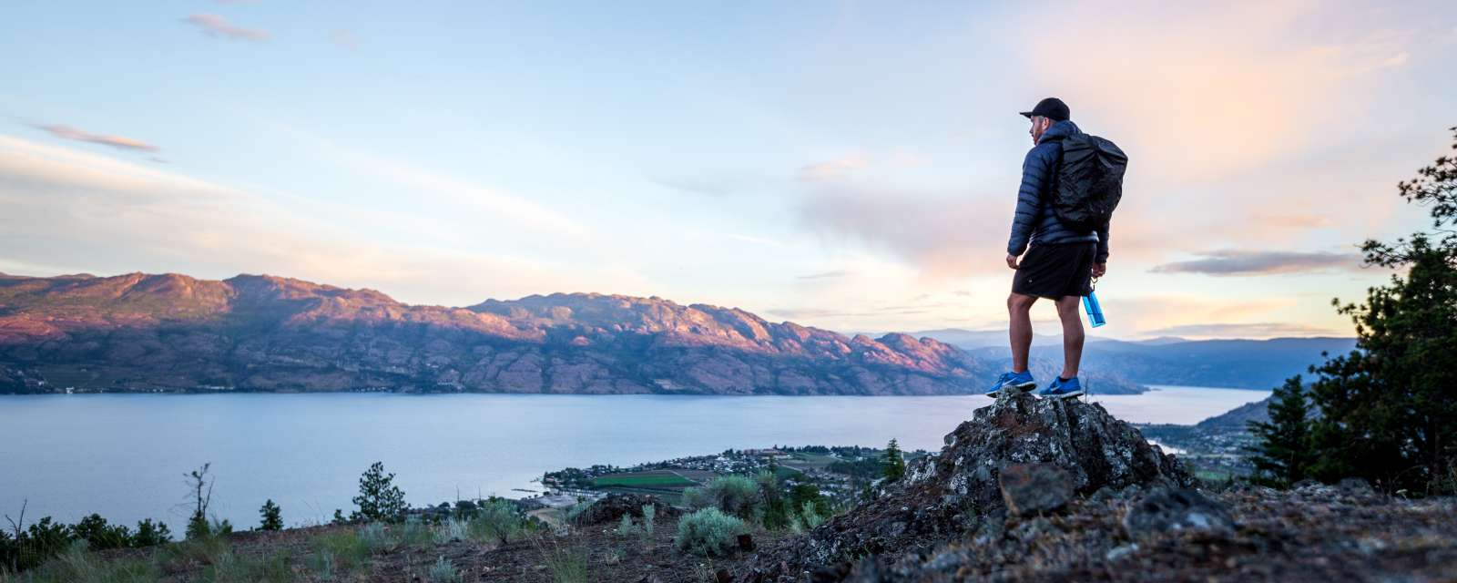

**2**

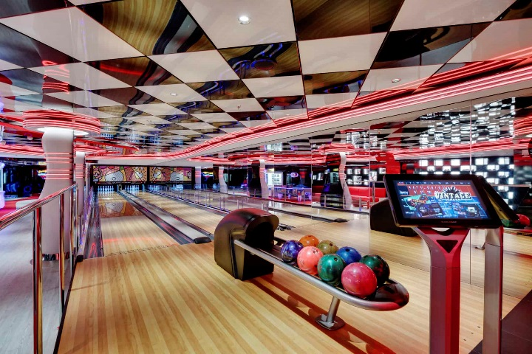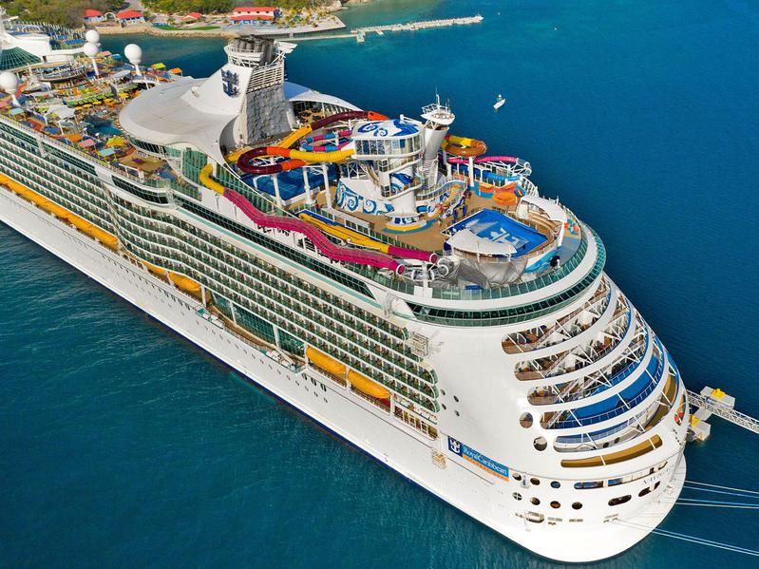

**3**

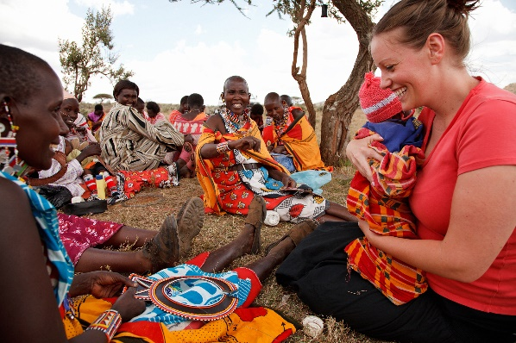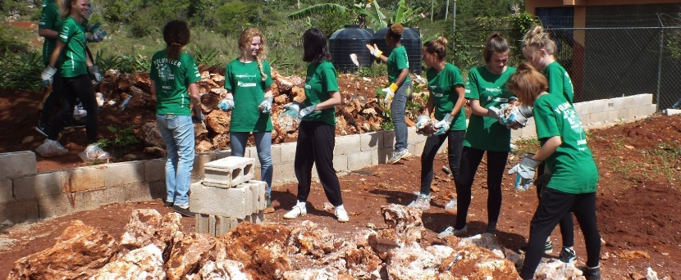

v

**Tutor’s copy**

**Trips around the world** Philippe Marcotte

**Tutor Instructions:** Ask your tutee the following questions. Answers are in italics and

highlighted.

**Assessment**

1. Have you ever travelled to another country? Explain the trip.
2. Do you like travelling? Why or why not?
3. What kind of trips do you like to take? Have you experienced any of them?

***Types of trips can be: camping-car, backpacking, cruise, rental car, kayaking/canoe trip, etc…***

1. What kind of attractions do you like to visit when you travel? Why?

***Type of attractions can be: cultural/historical, outdoor experiences, party, relaxation***

**Theory**

1. Have you ever gone on a **backpacking** trip? If not, would you like to try it?
2. Would you like to do the Disney **cruise?** Why?
3. Did you ever miss a **flight**? If yes, where were you going? What happened? If not, describe how you would feel about missing a flight.
4. When a flight is too long, some people must do a **stopover** in another country. Has it ever happened to you? Would you take time to visit this country?

**Controlled and communicative exercises**

1. Look at the different pictures about different types of trip.
2. What do you see in the pictures?
3. What types of trips are they?
4. Have you ever experienced any of them?

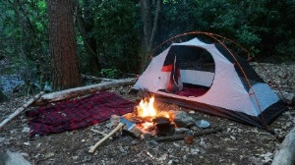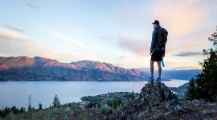**1**

**Questions about trip type 1:**

1. What type of trip is described in the pictures? (***Camping)***
2. What is the main reason people love to camp? *(To explore wildlife and do outdoor activities)*
3. What is the guy in the second picture doing? ***(Hiking***) Do you like hiking? Explain.
4. What should you bring during a camping trip? ***(Tent, sleeping bag, food, flashlight,)***
5. Do you think you would be a good camping cook? Why or why not?

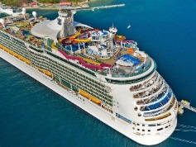

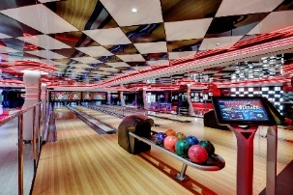

**2**

**Questions about trip type 2:**

1. What type of trip is described in the pictures? ***(Cruise)***
2. According to you, what activities can we do on a cruise boat?
3. Why do you think people love to do a cruise trip?
4. Do you think you can get out of the boat during a cruise?

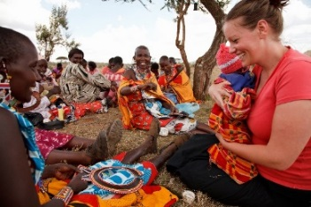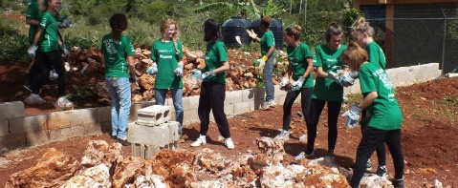

**3**

**Questions about trip type 3:**

1. What type of trip is described in the pictures? ***(Volunteer trip***)
2. What are the reasons people would do a volunteer trip?

***(Help people in difficulty, discover a completely new culture in a non-touristic way, travel for cheap because volunteering is normally free of charge concerning food and lodging)***

1. What are the benefits of doing a volunteering trip?

(***Learn a new language/culture, create a solid bond with complete strangers, satisfaction of helping people)***

1. What are the qualities a volunteer should have/will develop during volunteering? Why?

***(Open-mindedness for different culture, patience to explain, use creativity to solve problems, etc...)***

1. Would you like to do a volunteering trip? Why or why not?

**Production Task**

1. Which one of the three trips would you enjoy the most? Why?
2. Which one of the trips would you enjoy the least? Why?
3. Where would your dream trip be? Why? Would it be a backpacking trip or an expensive trip? Explain the activities you would do.

**Vocabulary Review**

1. Would you like to be work as part in a cruise **crew**? Why or why not?
2. Do you like **hiking**? Where would you recommend going hiking?
3. Have you ever encountered a **language barrier**? Where was it and how did you overcome it?
4. Have you ever done **volunteering**? How was it? How did the people react?
5. Is **wildlife** conservation important for you? Explain why. If yes, how can we protect it?