Penelope Stuyck

**Sleep for students**

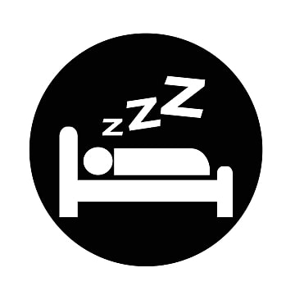

**Introduction Questions**

1. On average, how many hours of sleep do you get every night?
2. Are you a morning person or a night owl?
3. Do you have trouble waking up early?
4. Is there somebody around you who is a morning person?
5. Do you have a morning routine? If so, describe it.
6. Do you have a night routine? If so, describe it.

**Vocabulary Theory**

Complete the grid below.

|  |  |
| --- | --- |
| **English** | **French** |
| Schedule |  |
| Early |  |
| Nap |  |
| Drowsy |  |
| Behavior |  |
| Improve |  |
| Increase |  |
| Issues |  |

Using the words presented above, complete the following sentences:

1. I have __________ with my computer. It won’t turn on anymore!
2. I was tired this afternoon, so I took a __________.
3. I’m sorry, my __________ doesn’t allow me to meet with you today.
4. I arrived 10 minutes __________ yesterday.
5. I still need to __________ to pass my class this semester.
6. I didn’t sleep well last night so I’m __________ today.
7. Your __________ at the park was unacceptable!
8. You need to __________ the temperature of the water to make it boil.

Take turns asking each other the following questions:

1. Do you sometimes have issues with your computer?
2. How often do you take naps?
3. Do you have a good sleep schedule?
4. Do you feel drowsy at the moment?
5. Do you think your English skills have improved since the beginning of the session?
6. When you were young, did your parents reward you for good behavior or punish you for bad behavior?

**Facts about sleep**

Read the first paragraph, summarize it and then do the same for the second paragraph.

Most people know that teens and young adults need eight to ten hours of sleep every day. Getting enough sleep is very important especially for students since it can directly impact academic performances. Getting enough sleep helps with concentration and can stimulate creativity. It also improves memory and analytical thought.

Not getting enough sleep can increase the risk of developing physical or mental health problems such as anxiety or even depression. It can also make attention or behavior issues worst. Also, not sleeping enough at night will make you drowsy during the day and impact productivity.

**Tips to sleep better**

After reading each tip, discuss whether or not you already do it.

* Keep the same sleep schedule on weekdays and weekends
* Have a night routine to prepare you for bedtime
* Do a relaxing activity before going to sleep
* Turn off electronics like your phone or computer at least 30 minutes before bedtime
* Don’t drink caffeinated drinks at least 6 hours before bedtime
* Avoid taking naps longer than 30 minutes during the day
* Try to be active during the day but avoid physical activity too late in the day

**Text questions**

After reading “Facts about sleep” and “Tips to sleep better”, answer the following questions.

1. How many hours of sleep do students usually need every day?

Do you sleep fewer or more hours than the recommended amount?

Do you think it is possible for you to respect that amount with your current schedule?

1. In the text “Facts about sleep”, summarize the negative effects of lack of sleep for students and the positive effects of good sleep for students.

Do you have trouble concentrating in school?

Do you sometimes feel drowsy during the day?

**Activity**

Read both scenarios and answer the questions.

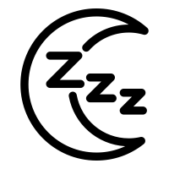

**Marie**

Marie is a college student. Right after dinner, she took an hour-long nap and when she woke up from her nap, she got coffee for an energy boost. She had a paper to write for school, so she worked on her computer all night. At 1am, she finally finished her paper, and she went to bed directly after. She woke up at 7 the next morning and went to school.

**William**

William is also a college student. In the afternoon he went to his soccer practice. After diner, he did his homework. When he finished his homework, he watched Tik Toks on his phone. At 9pm he turned off his phone and went to take a shower just like he does every night. Before bedtime he read a book to relax and went to sleep at 10pm. He woke up at 7 the next morning and went to school.

Whose scenario was the best? Whose scenario was the worst?

Explain the good or bad aspects of each scenario

|  |  |
| --- | --- |
| Marie’s scenario | William’s scenario |
| Good or Bad | Good or Bad |
|  |  |

**Questions about you**

1. Are you more like Marie or William?
2. Are there techniques listed in “Tips to sleep better” that you already use? What are they?
3. What techniques would you like to try to improve your sleep quality? Why?
4. What techniques do you think will be the most difficult for you to do? Why?
5. Do you notice differences when you sleep less or more than you usually do?