Tutee’s copy.



 

Social Media

**Assessment**

**Ask each other the following questions.**

1. What social media do you use? (Facebook, Instagram, Snapchat, Tiktok, Pinterest…)
2. What social media is your favorite? Explain why.
3. How much time do you spend on social media in a day? Do you think it is a lot?

**Theory**

**Ask each other the following questions.**

1. Do you **follow** some **content creators** on social media? Who are the content creators you follow? Why do you follow them?
2. Do you think there are too many **ads** on social media? Do those ads influence you to buy things? Did you ever buy something because it was on social media? What did you buy? Did you really need it?
3. What does **cyberbullying** mean? Did you ever experience cyberbullying?

Do you think cyberbullying is **worse** than physical bullying? Why or why not?

**Controlled and communicative exercises**

**Circle the answer that matches with you.**

1. **Why do you use your social media?**
2. **To share my opinion about a controversial subject.**
3. **To meet new people.**
4. **To find entertaining content.**
5. **To share photos or videos.**
6. **To stay informed on the latest news.**
7. **Other reasons: __________________**
8. **How many times do you post a photo or a video on your social media?**
9. **Once a day or more**
10. **Once a week.**
11. **Once a month.**
12. **2 to 5 times a year.**
13. **Once a year.**
14. **Do you use photoshop on the photos you post on social media?**
15. **Always.**
16. **Only when there is a detail that I don’t like.**
17. **Never, I don’t agree with photoshop.**
18. **What are you afraid of on social media?**
19. **Cyberbullying**
20. **Social listening**
21. **Hacking**
22. **Not be able to control where my personal information goes.**

**Production task**

**Let’s debate!**

Take a look at the pictures. Describe them and answer the questions.



This picture has no known author.

* What is happening in the picture?
* Do you think people give too much personal information on their social media accounts?

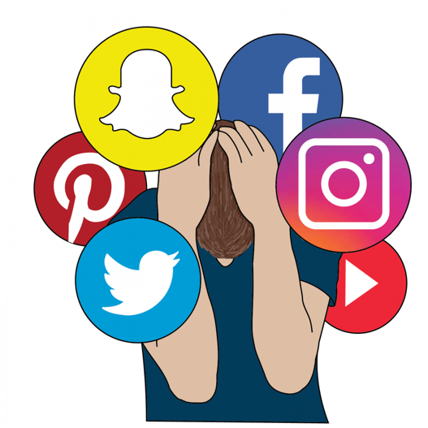

https://medium.com/@annmarie.jones/problematic-social-media-use-and-its-effects-on-young-individuals-c57a160167dc

* What is happening in the picture?
* If you had to keep only one social media, which one would you keep?

Why?



http://www.samflynn.co.uk/2015/04/22/spending-too-much-time-on-social-media/

* What is happening in the picture?
* Do you think you spend too much of your time on social media?