Tutor’s copy



 

**Social Media Theme-based Lesson**

**Assessment**

**Ask each other the following questions.**

1. What social media do you use? (Facebook, Instagram, Snapchat, TikTok, Pinterest…)
2. What social media is your favorite? Explain why.
3. How much time do you spend on social media in a day? Do you think it is a lot?

**Theory**

**Ask each other the following questions.**

1. Do you **follow** some **content creators** on social media? Who are the content creators you follow? Why do you follow them?
2. Do you think there are too many **ads** on social media? Do those ads influence you to buy things? Did you ever buy something because it was on social media? What did you buy? Did you really need it?
3. What does **cyberbullying** mean? Did you ever experience cyberbullying?

Do you think cyberbullying is **worse** than physical bullying? Why or why not?

**Controlled and communicative exercises**

**Circle the answer that matches with you.**

1. **Why do you use your social media?**
2. **To share my opinion about a controversial subject.**
3. **To meet new people.**
4. **To find entertaining content.**
5. **To share photos or videos.**
6. **To stay informed on the latest news.**
7. **Other reasons: __________________**

**Questions to ask:**

* ***In your opinion, what is the most popular reason for the use of social media?***
* ***Do you think you use your social media the same way your parents do? Why or why not?***
* ***What do you think your parents do on social media?***

1. **How often do you post a photo or a video on social media?**
2. **Once a day or more.**
3. **Once a week.**
4. **Once a month.**
5. **2 to 5 times a year.**
6. **Once a year.**

**Questions to ask:**

* ***Why do you post photos or videos on social media?***
* ***Why do your friends post photos or videos on social media?***
* ***Do you believe that posting photos or videos on a regular basis can make you famous on social media? Why or why not?***

1. **Do you use photoshop on the photos you post on social media?**
2. **Always.**
3. **Only when there is a detail that I don’t like.**
4. **Never, I don’t agree with photoshop.**

**Questions to ask:**

* ***Why would you use photoshop?***
* ***Why would you not use photoshop?***
* ***Do your friends use photoshop to modify their photos? Why are they using it?***
* ***Do you think there is too much photoshop on social media?***

1. **What are you afraid of on social media?**
2. **Cyberbullying**
3. **Hacking**
4. **To not be able to control where my personal information goes.**

**Questions to ask:**

* ***Do you think social media is a safe place for our personal information? Why or why not?***
* ***Do you think hacking a computer is a crime? Do you think hacking is comparable to stealing? Why or why not?***
* ***Do you think we are well informed on those subjects? Should we have a class on how to behave on social media? Why or why not?***

**Production task**

**Let’s debate!**

Take a look at the pictures. Describe them and answer the questions.

*A woman is on her cellphone. She is sharing some personal information on her cellphone.*

*There is a thief that is stealing the personal information of the woman. So, maybe a cellphone is not a safe place for our personal information.*



This picture has no known author.

* What is happening in the picture?
* Do you think people give too much personal information on their social media accounts?

*Question to ask: What type of information should you never give?*

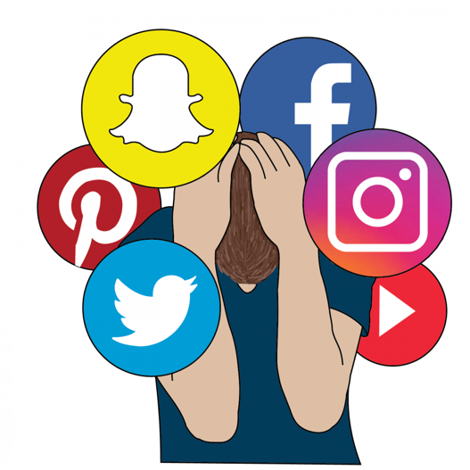

*The picture represents a person who seems depressed because of his social media.*

*Social media seems to bring him anxiety.*

https://medium.com/@annmarie.jones/problematic-social-media-use-and-its-effects-on-young-individuals-c57a160167dc

* What is happening in the picture?
* If you had to keep only one social media, which one would you keep?

Why?



*There is a clock. The hours are substituted by the logo of some social media. It represents the time we are spending on social media.*

http://www.samflynn.co.uk/2015/04/22/spending-too-much-time-on-social-media/

* What is happening in the picture?
* Do you think you spend too much of your time on social media?

*Question to ask*: *What should you do to reduce the time you spend on social media?*

**Vocabulary review**

Would you like to be **famous** on social media? Why or why not?

If you could **follow** only one **content creator** who would it be? Why?

What is your favorite social media if you want **entertaining content**? Explain why?